Docker swarm

Docker swarm:
Docker Swarm is a clustering and scheduling tool for Docker containers. With Swarm, IT administrators and developers can establish and manage a cluster of Docker nodes as a single virtual system.

Why docker swarms:
To keep this simple, imagine that you had to run hundreds of containers.
You can easily see that if they are running in a distributed mode, there are multiple features that you will need from management angle to make sure that the cluster is up and running, is healthy and more.
* Health Checks on the Containers
* Launching a fixed set of Containers for a particular Docker image
* Scaling the number of Containers up and down depending on the load
* Performing rolling update of software across containers

what is swarm
The cluster management and orchestration features embedded in the Docker Engine are built using swarmkit.
Swarmkit is a separate project which implements Docker’s orchestration layer and is used directly within Docker.
swarm consists of multiple Docker hosts which run in swarm mode and act as managers and workers . A given Docker host can be a manager, a worker, or perform both roles.

When you create a service, you define its optimal state (number of replicas, network and storage resources available to it, ports the service exposes to the outside world, and more).
Docker works to maintain that desired state. For instance, if a worker node becomes unavailable, Docker schedules that node’s tasks on other nodes.
A task is a running container which is part of a swarm service and managed by a swarm manager, as opposed to a standalone container.

what is a node
A node is an instance of the Docker engine participating in the swarm. You can also think of this as a Docker node. You can run one or more nodes on a single physical computer or cloud server, but production swarm deployments typically include Docker nodes distributed across multiple physical and cloud machines.

service and tasks
A service is the definition of the tasks to execute on the manager or worker nodes. It is the central structure of the swarm system and the primary root of user interaction with the swarm.

When you create a service, you specify which container image to use and which commands to execute inside running containers. A task carries a Docker container and the commands to run inside the container. It is the atomic scheduling unit of swarm. Manager nodes assign tasks to worker nodes according to the number of replicas set in the service scale. Once a task is assigned to a node, it cannot move to another node. It can only run on the assigned node or fail.
load balancing
Containers can be exposed outside of the cluster through the Swarm load balancer. The Docker Swarm load balancer runs on every node and can load balance requests across any of the containers on any of the hosts in the cluster.

Install Docker in your machines like Manager and Nodes and start the docker service in both machines

Service docker start
Systemctl docker start

Run the following commands to create a new machine

$ docker swarm init <manager ip>
It generate a token like

$ docker swarm init

Swarm initialized: current node (dxn1zf6l61qsb1josjja83ngz(nodeId)) is now a manager.
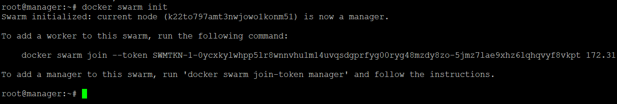
To add a worker to this swarm, run the following command:

docker swarm join \
--token SWMTKN-1-49nj1cmql0jkz5s954yi3oex3nedyz0fb0xx14ie39trti4wxv-8vxv8rssmk743ojnwacrr2e7c \192.168.99.100:2377
Add generate token to worker node

While joining node to swarm manager its getting error

To check the network in docker manager

Follow these commands

netstat -ntulp | grep dockerd
-
Open the ports in Manager machine
Run on Node
telnet <swarm manager leader private ip> 2377

telnet 172.31.18.8 2377

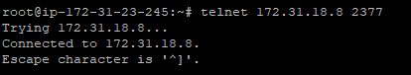

The following ports must be available. On some systems, these ports are open by default.

TCP port 2377 for cluster management communications
TCP and UDP port 7946 for communication among nodes
UDP port 4789 for overlay network traffic

To view the current state of the swarm
$ docker info
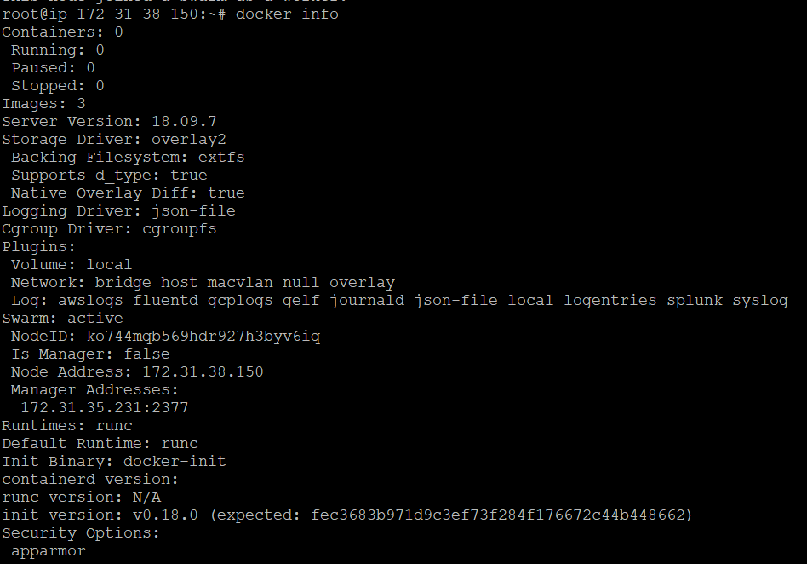

To see the information about nodes in Manager
$ docker node ls
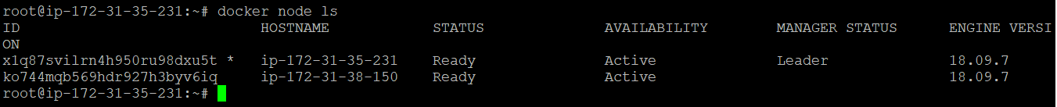

leave the node to swarm
$ docker swarm leave –force
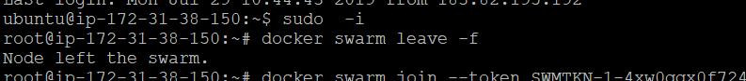

deploy services to swarm

Run the command on manager
$ docker service create --replicas <no of instance> --name servicename ping docker.com
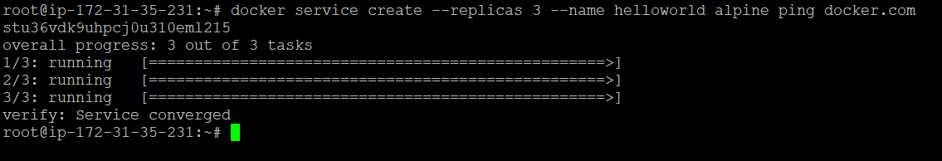

ex: docker service create --replicas 3 --name helloworld alpine ping
docker.com

To see the service run the command

$ docker service ls
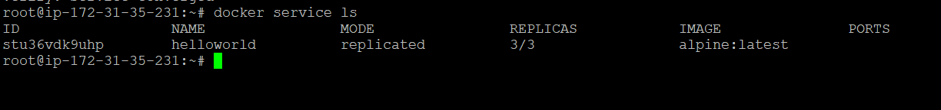
Inspect a service on the swarm
To see the information about service

$ docker service inspect --pretty <SERVICE-ID>

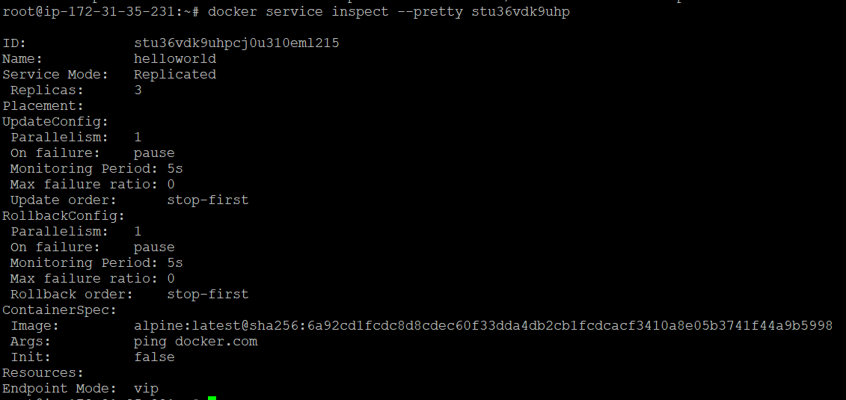

--pretty: To return the service details in json format, run the same command without the --pretty flag.

To see which nodes are running the service

$ docker service ps <SERVICE-ID>

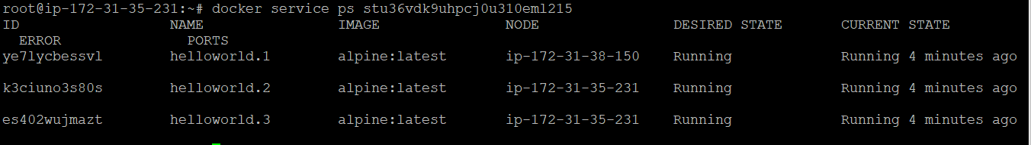

scale the service in the swarm

$ docker service scale <SERVICE-ID>=<NUMBER-OF-TASKS>

ex:$ docker service scale helloworld=5

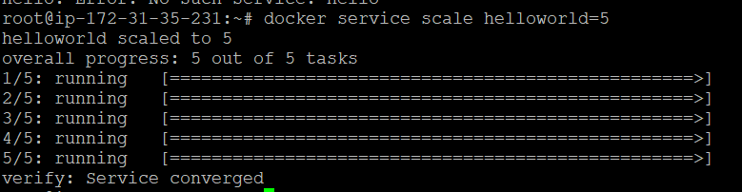

docker service ps helloworld

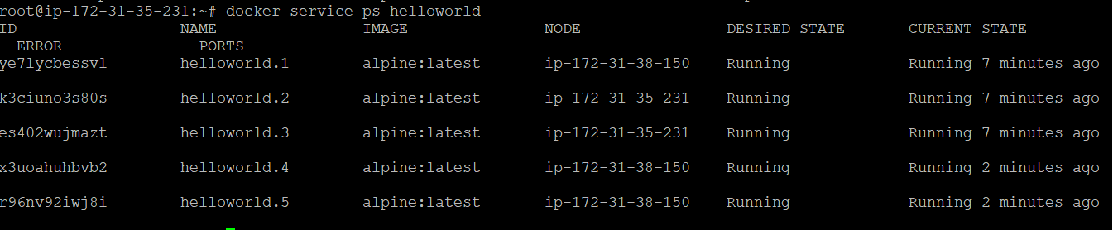

deleting the service
$ docker rm service-id

ex: docker service rm helloworld
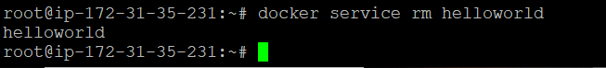
applying rolling updates to a service

$ docker service create --replicas 3 --name redis --update-delay 10s redis:3.0.6

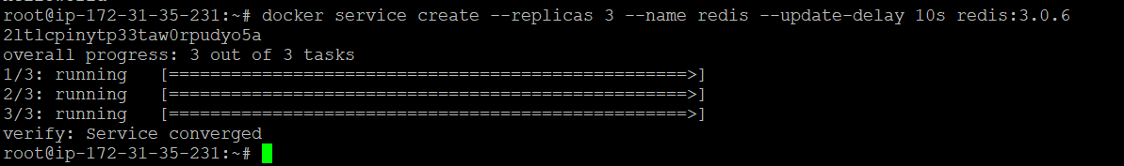

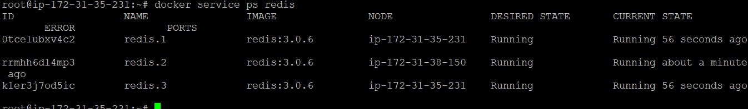

now you can update the container image to redis
If you want to update the services image 3.0.6 to 3.0.7

$ docker service update --image redis:3.0.7 redis

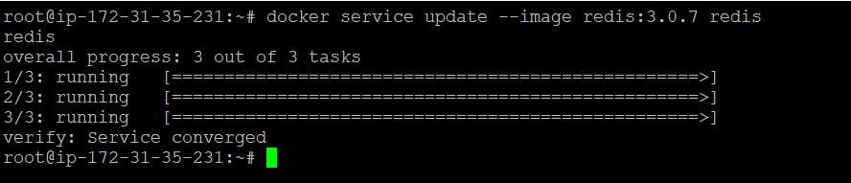

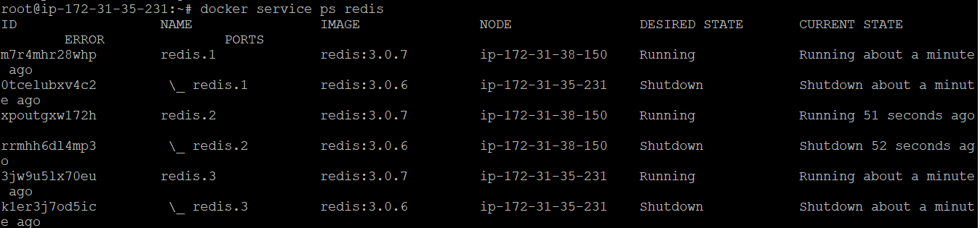

To see the docker image state redis

Run the command

$ docker service inspect --pretty redis

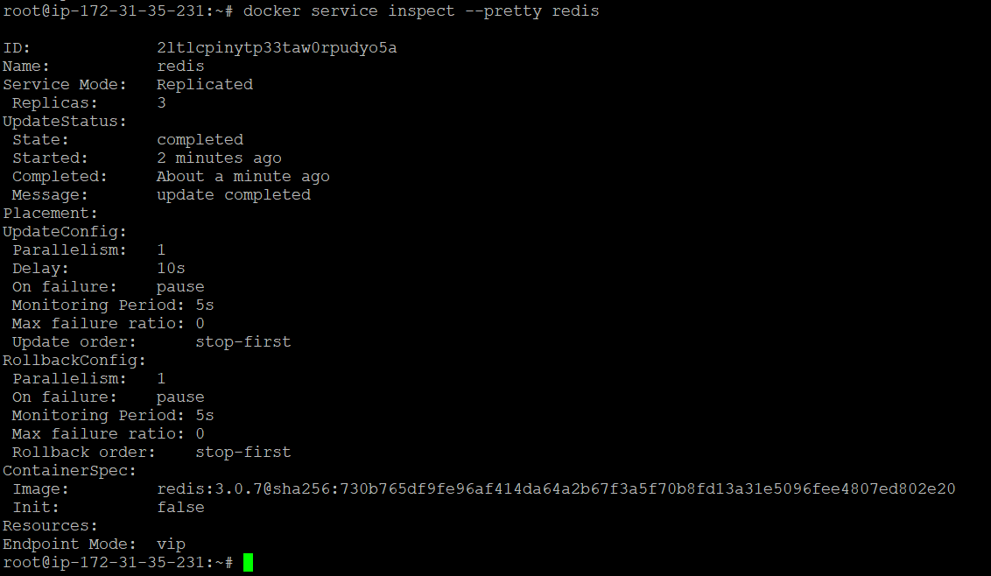

Drain a node to the swarm

If the node is ACTIVE, it is ready to accept tasks from the Master i.e. Manager.

Run the command To see the Node status

$ docker node ls

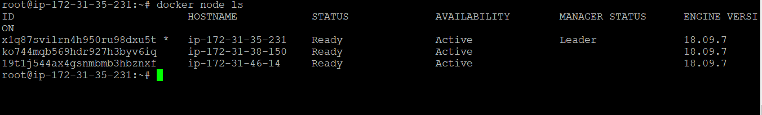
To see how the manager assign worker to node
$ docker service ps web
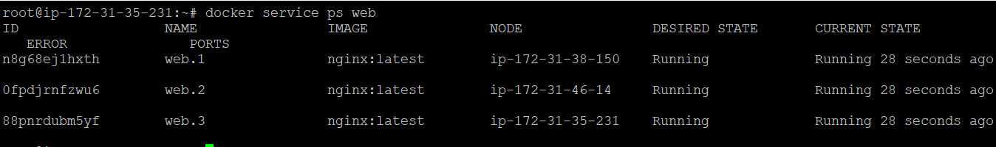

You can see that their AVAILABILITY is set to READY.
As per the documentation, When the node is active, it can receive new tasks:
during a service update to scale up
during a rolling update
when you set another node to Drain availability
when a task fails on another active node
But sometimes, we have to bring the Node down for some maintenance reason. This meant by setting the Availability to Drain mode. Let us try that with one of our nodes.
Now, let us set the Availability to DRAIN. When we give that command, the Manager will stop tasks running on that node and launches the replicas on other nodes with ACTIVE availability.

Toset the Hostname
hostname worker1
run the command in manager.

$ docker node update --availability drain <worker1>

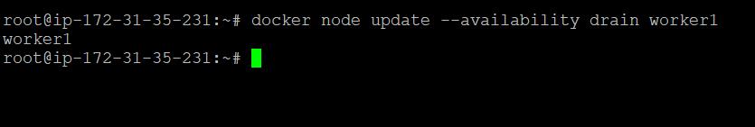
To see the node state

$ docker node ls
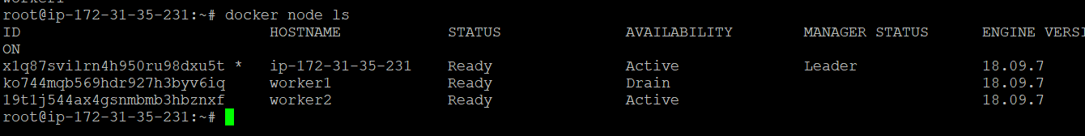

Run docker node update --availability active <NODE-ID> to return the drained node to an active state:

$ Docker node update –-availability active worker1

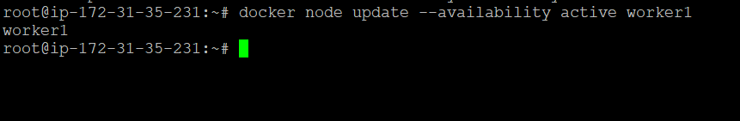

$ Docker node ls
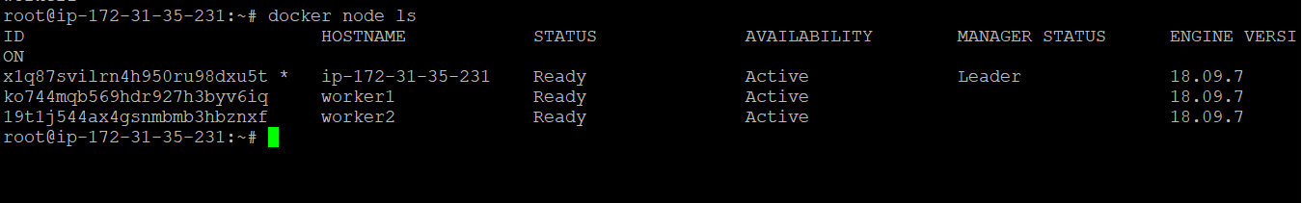
we can create a service by using yml files also

mkdir compose test
cd composetest
touch docker-compose.yml
vi docker-compose
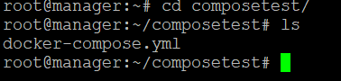

Version:”3”
Services:
Web: nginx
Ports:
- 8080:80

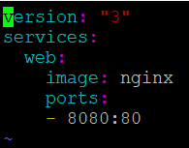

$ docker stack deploy -c docker-compose.yml worker1

To check services
Docker service ls
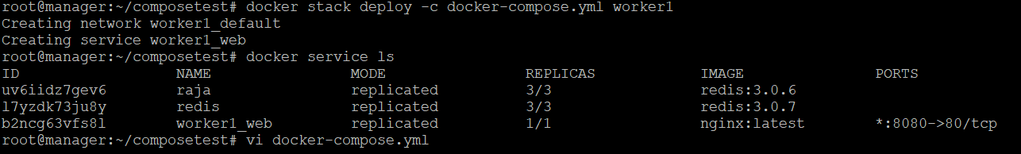

(worker1) is the name of your applying worker node

To see the web app:
